XÂY DỰNG ỨNG DỤNG TRÊN ANDROID

Project: Xây dựng ứng dụng Quản lý sinh viên với giao diện như sau:

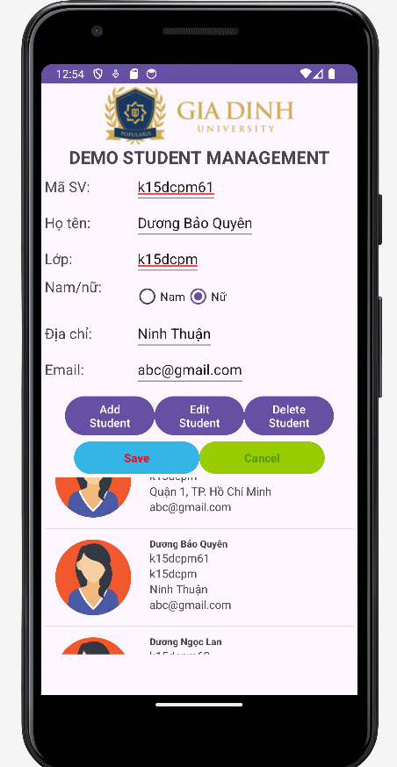

Yêu cầu: Giao diện chính hiển thị danh sách sinh viên. Khi click vào 1 sinh viên nào đó trong danh sách sẽ hiển thị chi tiết vào các ô text phía trên.

Có các chức năng: Thêm, Sửa, Xóa sinh viên.

Nâng cao:

1. Tự động sinh ra một số lượng sinh viên theo mong muốn (để test)
2. Kết nối thêm, sửa, xóa trong cơ sở dữ liệu
3. Kết nối thêm, sửa, xóa sv với backend

Giải quyết:

Bước 1: Tạo project mới

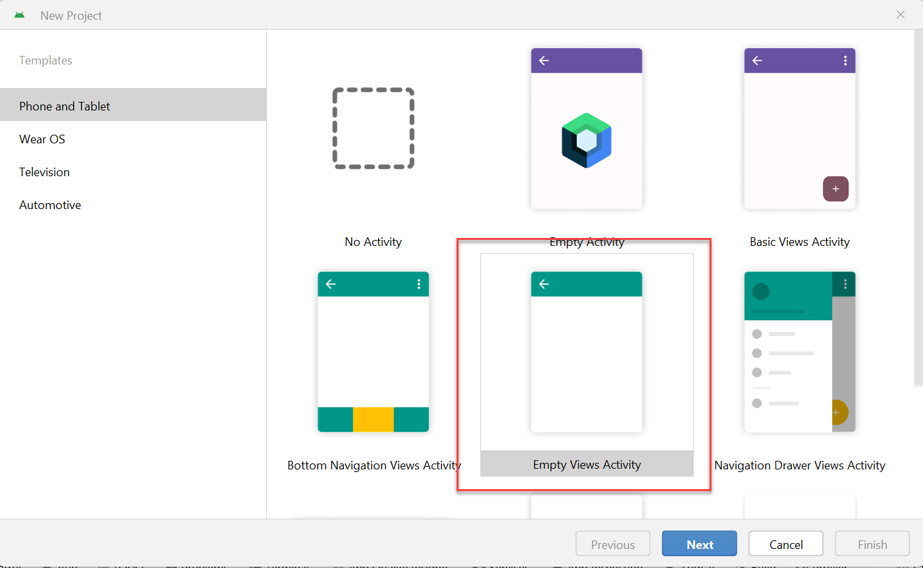

Bước 2: Thiết kế Layout cho Activity Main

*<?*xml version="1.0" encoding="utf-8"*?>*<ScrollView xmlns:android="http://schemas.android.com/apk/res/android"  
 xmlns:app="http://schemas.android.com/apk/res-auto"  
 xmlns:tools="http://schemas.android.com/tools"  
 android:layout_width="match_parent"  
 android:layout_height="match_parent"  
 tools:context=".MainActivity">  
  
 <LinearLayout  
 android:layout_width="match_parent"  
 android:layout_height="match_parent"  
 android:orientation="vertical"  
 android:layout_margin="2pt">  
  
 <ImageView  
 android:layout_width="wrap_content"  
 android:layout_height="wrap_content"  
 android:layout_gravity="center"  
 android:src="@drawable/logo"  
 />  
 <TextView  
 android:layout_width="wrap_content"  
 android:layout_height="wrap_content"  
 android:text="DEMO STUDENT MANAGEMENT"  
 android:textSize="10pt"  
 android:textStyle="bold"  
 android:layout_gravity="center"/>  
  
 <LinearLayout  
 android:layout_width="match_parent"  
 android:layout_height="wrap_content"  
 android:orientation="horizontal">  
  
 <TextView  
 android:layout_width="45pt"  
 android:layout_height="wrap_content"  
 android:textSize="8pt"  
 android:text="Mã SV:"/>  
  
 <EditText  
 android:layout_width="wrap_content"  
 android:layout_height="wrap_content"  
 android:id="@+id/txtStudentNo"  
 android:textSize="8pt"  
 android:text="..."/>  
  
 </LinearLayout>  
  
 <LinearLayout  
 android:layout_width="match_parent"  
 android:layout_height="wrap_content"  
 android:orientation="horizontal">  
  
 <TextView  
 android:layout_width="45pt"  
 android:layout_height="wrap_content"  
 android:textSize="8pt"  
 android:text="Họ tên:"/>  
  
 <EditText  
 android:layout_width="wrap_content"  
 android:layout_height="wrap_content"  
 android:id="@+id/txtName"  
 android:textSize="8pt"  
 android:text="..."/>  
  
 </LinearLayout>  
  
 <LinearLayout  
 android:layout_width="match_parent"  
 android:layout_height="wrap_content"  
 android:orientation="horizontal">  
  
 <TextView  
 android:layout_width="45pt"  
 android:layout_height="wrap_content"  
 android:textSize="8pt"  
 android:text="Lớp:"/>  
  
 <EditText  
 android:layout_width="wrap_content"  
 android:layout_height="wrap_content"  
 android:id="@+id/txtClassNo"  
 android:textSize="8pt"  
 android:text="..."/>  
  
 </LinearLayout>  
  
 <LinearLayout  
 android:layout_width="match_parent"  
 android:layout_height="wrap_content"  
 android:orientation="horizontal">  
  
 <TextView  
 android:layout_width="45pt"  
 android:layout_height="wrap_content"  
 android:textSize="8pt"  
 android:text="Địa chi:"/>  
  
 <EditText  
 android:layout_width="wrap_content"  
 android:layout_height="wrap_content"  
 android:id="@+id/txtAddress"  
 android:textSize="8pt"  
 android:text="..."/>  
  
 </LinearLayout>  
  
 <LinearLayout  
 android:layout_width="match_parent"  
 android:layout_height="wrap_content"  
 android:orientation="horizontal">  
  
 <TextView  
 android:layout_width="45pt"  
 android:layout_height="wrap_content"  
 android:textSize="8pt"  
 android:text="Email:"/>  
  
 <EditText  
 android:layout_width="wrap_content"  
 android:layout_height="wrap_content"  
 android:id="@+id/txtEmail"  
 android:textSize="8pt"  
 android:text="..."/>  
  
 </LinearLayout>  
  
 <LinearLayout  
 android:layout_width="match_parent"  
 android:layout_height="wrap_content"  
 android:orientation="horizontal">  
 <TextView  
 android:layout_width="wrap_content"  
 android:layout_height="wrap_content"  
 android:width="50pt"  
 android:textSize="8pt"  
 android:text="Nam/nữ:"  
 />  
 <RadioGroup  
 android:layout_width="wrap_content"  
 android:layout_height="wrap_content"  
 android:id="@+id/rd_sex"  
 android:orientation="horizontal">  
 <RadioButton  
 android:layout_width="wrap_content"  
 android:layout_height="wrap_content"  
 android:id="@+id/rd_Male"  
 android:checked="true"  
 android:text="Nam"/>  
  
 <RadioButton  
 android:layout_width="wrap_content"  
 android:layout_height="wrap_content"  
 android:id="@+id/rd_Famale"  
 android:text="Nữ"/>  
  
  
 </RadioGroup>  
  
  
 </LinearLayout>  
  
  
 <LinearLayout  
 android:layout_width="wrap_content"  
 android:layout_height="wrap_content"  
 android:layout_gravity="center"  
 android:orientation="horizontal"  
 android:paddingTop="3pt"  
 >  
 <Button  
 android:layout_width="wrap_content"  
 android:layout_height="wrap_content"  
 android:text="Add Student"  
 android:id="@+id/bntAdd"  
 android:width="50pt"/>  
  
 <Button  
 android:layout_width="wrap_content"  
 android:layout_height="wrap_content"  
 android:text="Edit Student"  
 android:id="@+id/bntEdit"  
 android:width="50pt"/>  
  
 <Button  
 android:layout_width="wrap_content"  
 android:layout_height="wrap_content"  
 android:text="Delete Student"  
 android:id="@+id/bntDelete"  
 android:width="50pt"/>  
  
 </LinearLayout>  
  
 <LinearLayout  
 android:layout_width="wrap_content"  
 android:layout_height="wrap_content"  
 android:layout_gravity="center"  
 android:orientation="horizontal"  
 >  
 <Button  
 android:layout_width="wrap_content"  
 android:layout_height="wrap_content"  
 android:text="Save"  
 android:backgroundTint="@android:color/holo_blue_light"  
 android:textStyle="bold"  
 android:textColor="#f70622"  
  
 android:id="@+id/bntSave"  
 android:width="70pt"/>  
  
 <Button  
 android:layout_width="wrap_content"  
 android:layout_height="wrap_content"  
 android:textColor="#579a08"  
 android:backgroundTint="@android:color/holo_green_light"  
 android:textStyle="bold"  
 android:text="Cancel"  
  
 android:id="@+id/bntCancel"  
 android:width="70pt"/>  
  
 </LinearLayout>  
  
 <ListView  
 android:id="@+id/lv_lststudents"  
 android:layout_width="match_parent"  
 android:layout_height="220dp" />  
  
  
 </LinearLayout>  
  
  
  
  
</ScrollView>

**Bước 3: Tạo Model**

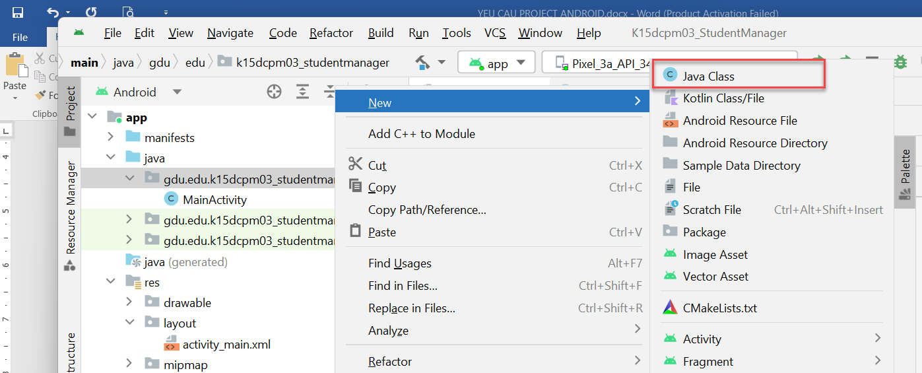

package gdu.edu.k15dcpm03_studentmanager;  
  
import java.util.ArrayList;  
import java.util.Random;  
  
public class Student  
{  
 private int id;  
 private String studentNumber;*/*Mã SV*/* private String fullName;*/* Họ tên */* private String classNo; */* Lớp */* private String address;*/*Địa chỉ*/* private String email; */*email*/* private boolean sex;*/*Giới tính*/* public Student(int id, String studentNumber, String fullName, String classNo, String address, String email, boolean sex) {  
 this.id = id;  
 this.studentNumber = studentNumber;  
 this.fullName = fullName;  
 this.classNo = classNo;  
 this.address = address;  
 this.email = email;  
 this.sex = sex;  
 }  
  
 public int getId() {  
 return id;  
 }  
  
 public void setId(int id) {  
 this.id = id;  
 }  
  
 public String getStudentNumber() {  
 return studentNumber;  
 }  
  
 public void setStudentNumber(String studentNumber) {  
 this.studentNumber = studentNumber;  
 }  
  
 public String getFullName() {  
 return fullName;  
 }  
  
 public void setFullName(String fullName) {  
 this.fullName = fullName;  
 }  
  
 public String getClassNo() {  
 return classNo;  
 }  
  
 public void setClassNo(String classNo) {  
 this.classNo = classNo;  
 }  
  
 public String getAddress() {  
 return address;  
 }  
  
 public void setAddress(String address) {  
 this.address = address;  
 }  
  
 public String getEmail() {  
 return email;  
 }  
  
 public void setEmail(String email) {  
 this.email = email;  
 }  
  
 public boolean isSex() {  
 return sex;  
 }  
  
 public void setSex(boolean sex) {  
 this.sex = sex;  
 }  
  
  
 private static String[] *ho*= {"Nguyễn", "Lê", "Trần", "Hồ", "Lều", "Đinh", "Mạc", "Văn", "Ninh", "Dương"};  
 private static String[] *ten_nam*= {"Anh", "Ngọc An", "Bình", "Quỳnh", "Hoài Ân", "Văn Toản", "Thắng", "Thịnh", "Trường", "Ngân"};  
 private static String[] *ten_nu*={"Ngọc Trinh", "Phương Trinh", "Hồng Vân", "Ky Duyên", "Lan Ngọc","Ngọc Lan", "Bảo Quyên", "Lệ Quyên","Hồng Nhung", "Ái Liên"};  
 private static String[] *diachi*={"371 Nguyễn Kiệm, P3, Gò Vấp","Lý Thường Kiêt, P.7, Quận 10", "Ninh Thuận", "Bình Thuận","Bình Chánh", "Quận 8","Quận 1, TP. Hồ Chí Minh", "Quận 7, TP.Hồ Chí Minh", "Đức Hòa, Long An","Gò Công Đông, Tiền Giang"};  
  
  
 private static int rd_namnu()  
 {  
 Random rand = new Random();  
 int randomNum = rand.nextInt((2));  
 return randomNum;  
 }  
 private static int random1()  
 {  
 Random rand = new Random();  
  
 *// nextInt as provided by Random is exclusive of the top value so you need to add 1* int randomNum = rand.nextInt((9) + 1);  
 return randomNum;  
 }  
  
 public static ArrayList<Student> gen_random_student(int size)  
 {  
 ArrayList<Student> lst=new ArrayList<Student>();  
 for (int i=0; i<size; i++)  
 {  
 int namnu=*rd_namnu*();  
 boolean sex=(namnu==1)?true:false;  
  
 String family=*ho*[*random1*()];  
 String address=*diachi*[*random1*()];  
 String name=sex?*ten_nam*[*random1*()] :*ten_nu*[*random1*()];  
Student student=new Student(i+1,"k15dcpm"+(i+1),family+" "+name,"k15dcpm",address,"abc@123.com",sex);

lst.add(student);  
 }  
 return lst;  
 }  
  
  
  
}

**Bước 4: Tạo view cho item list view (để hiển thị từng thành phần trên listview)**

Tạo Layout Resource File đặt tên là “**item_listview**”

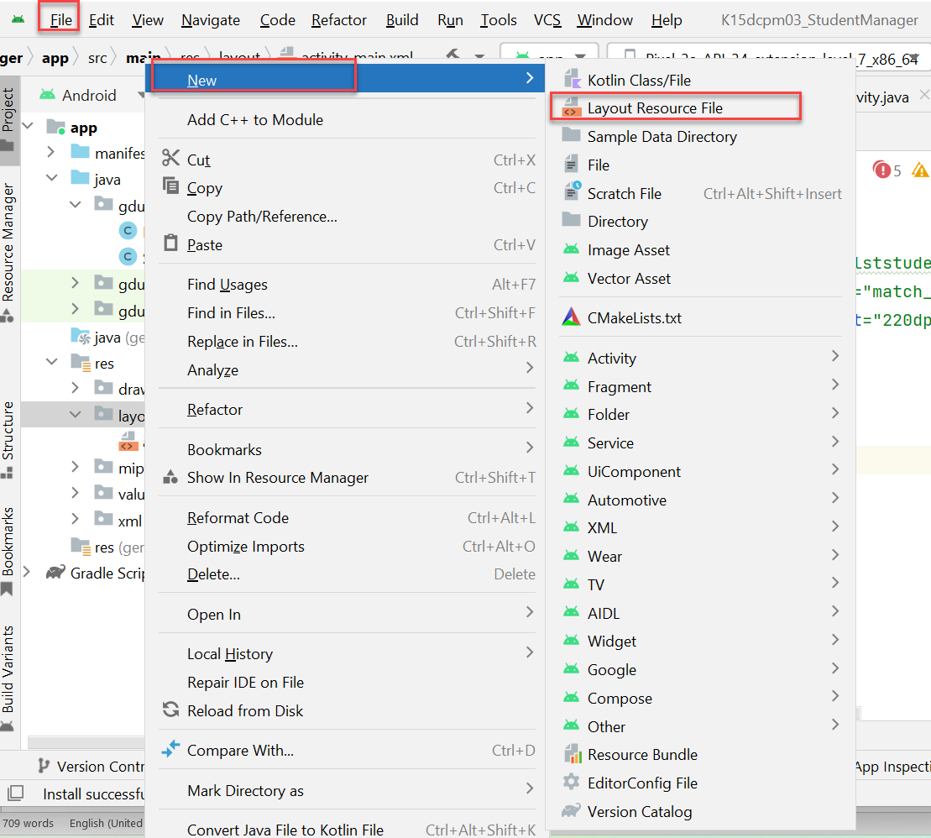

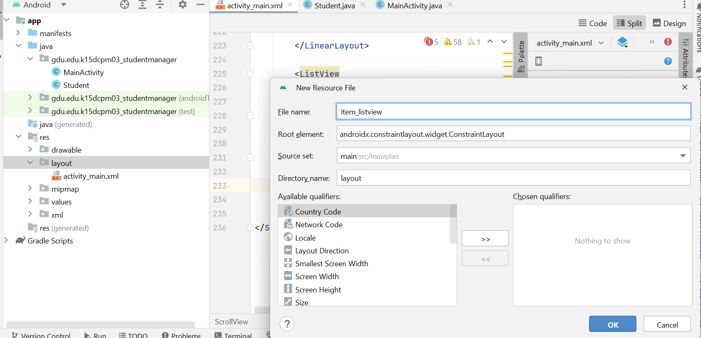

*<?*xml version="1.0" encoding="utf-8"*?>*<LinearLayout xmlns:android="http://schemas.android.com/apk/res/android"  
 android:layout_width="match_parent"  
 android:layout_height="wrap_content">  
  
 <LinearLayout  
 android:layout_width="match_parent"  
 android:layout_height="wrap_content"  
 android:layout_margin="10dp"  
 android:orientation="horizontal">  
 <ImageView  
 android:layout_width="100dp"  
 android:layout_height="100dp"  
 android:src="@drawable/man"  
 android:id="@+id/iv_avatar"/>  
  
 <LinearLayout  
 android:layout_width="wrap_content"  
 android:layout_height="wrap_content"  
 android:orientation="vertical"  
 android:layout_marginLeft="20dp">  
  
 <TextView  
 android:layout_width="wrap_content"  
 android:layout_height="wrap_content"  
 android:id="@+id/txtName"  
 android:text="Đinh Hoàng Gia"  
 android:textSize="12dp"  
 android:textStyle="bold"/>  
 <TextView  
 android:layout_width="wrap_content"  
 android:layout_height="wrap_content"  
 android:id="@+id/txtMaSV"  
 android:text="Mã SV: 1234"/>  
  
 <TextView  
 android:layout_width="wrap_content"  
 android:layout_height="wrap_content"  
 android:id="@+id/txtClass"  
 android:text="Lớp: k15dcpm"/>  
  
 <TextView  
 android:layout_width="wrap_content"  
 android:layout_height="wrap_content"  
 android:id="@+id/txtAddress"  
 android:text="Địa chỉ: 371 Nguyễn Kiệm"/>  
  
 <TextView  
 android:layout_width="wrap_content"  
 android:layout_height="wrap_content"  
 android:id="@+id/txtEmail"  
 android:text="Email: abc@123.com"/>  
 </LinearLayout>  
  
 </LinearLayout>  
  
</LinearLayout>

Viết 1 lớp class java để điều khiển

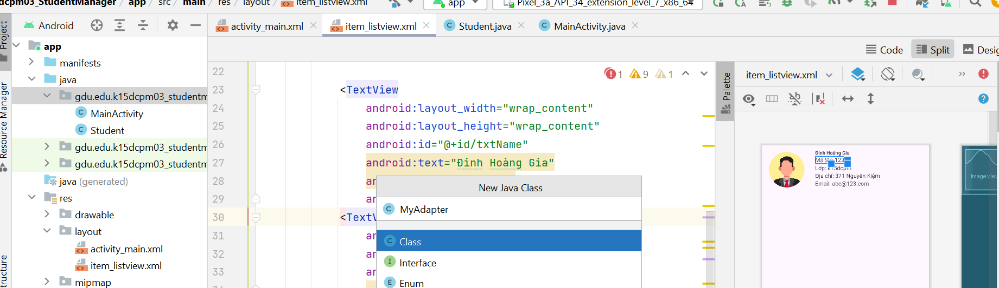

package gdu.edu.k15dcpm04_studentmanager;  
  
import android.content.Context;  
import android.view.LayoutInflater;  
import android.view.View;  
import android.view.ViewGroup;  
import android.widget.ArrayAdapter;  
import android.widget.ImageView;  
import android.widget.TextView;  
  
import java.util.ArrayList;  
  
public class MyAdapter extends ArrayAdapter<Student>  
{  
 private Context context;*/* Activity (tức là Form) cần xử lý */* private int resource;*/* File resouce item_listview mà mình định custom */* private ArrayList<Student> lststudent; */*List sv*/* public MyAdapter(Context context, int resource, ArrayList<Student> lststudent)  
 {  
 super(context,resource,lststudent);  
 this.context=context;  
 this.resource=resource;  
 this.lststudent=lststudent;  
 }  
  
 @Override  
 public View getView(int position, View current, ViewGroup parent) {  
 ViewHolder viewholder;  
  
 if (current==null)  
 {  
 current= LayoutInflater.*from*(context).inflate(resource,parent,false);  
 viewholder=new ViewHolder();  
 viewholder.iv_avatar=(ImageView) current.findViewById(R.id.*iv_avatar*);  
 viewholder.txtName=(TextView) current.findViewById(R.id.*txtName*);  
 viewholder.txtMaSV=(TextView) current.findViewById(R.id.*txtMaSV*);  
 viewholder.txtClass=(TextView) current.findViewById(R.id.*txtClass*);  
 viewholder.txtAddress=(TextView) current.findViewById(R.id.*txtAddress*);  
 viewholder.txtEmail=(TextView) current.findViewById(R.id.*txtEmail*);  
 *//Lưu lại viewholder* current.setTag(viewholder);  
 }  
 else  
 {  
 viewholder=(ViewHolder) current.getTag();  
 }  
  
 Student student=lststudent.get(position);  
 if (student.isSex())  
 viewholder.iv_avatar.setImageResource(R.drawable.*man*);  
 else viewholder.iv_avatar.setImageResource(R.drawable.*woman*);  
  
 viewholder.txtName.setText(student.getFullName());  
 viewholder.txtMaSV.setText(student.getStudentNumber());  
 viewholder.txtClass.setText(student.getClassNo());  
 viewholder.txtAddress.setText(student.getAddress());  
 viewholder.txtEmail.setText(student.getEmail());  
 return current;  
 };  
  
  
 public class ViewHolder  
 {  
 ImageView iv_avatar;  
 TextView txtName,txtMaSV,txtClass,txtAddress,txtEmail;  
 }  
  
  
  
  
  
}

**Quay trở lại MainActivity để viết code**

package gdu.edu.k15dcpm04_studentmanager;  
  
import androidx.appcompat.app.AlertDialog;  
import androidx.appcompat.app.AppCompatActivity;  
  
import android.content.DialogInterface;  
import android.os.Bundle;  
import android.view.View;  
import android.widget.AdapterView;  
import android.widget.Button;  
import android.widget.EditText;  
import android.widget.ListView;  
import android.widget.RadioButton;  
import android.widget.RadioGroup;  
import android.widget.Toast;  
  
import java.util.*;  
  
  
  
public class MainActivity extends AppCompatActivity {  
  
 ArrayList<Student> dssinhvien;  
 ListView lv_lststudents;  
 MyAdapter myadapter;  
  
 EditText txtMaSV,txtHoten,txtClass,txtAddress,txtEmail;  
 RadioButton rd_Male,rd_Famale;  
 RadioGroup rd_sex;  
 Button bntAdd,bntEdit,bntDelete, bntSave,bntCancel;  
  
 int id=0, action=0;;  
 Student student;  
  
  
 private void DisplayStudent(Student student)  
 {  
 txtMaSV.setText(student.getStudentNumber());  
 id=student.getId();  
 txtHoten.setText(student.getFullName());  
 txtClass.setText(student.getClassNo());  
 txtAddress.setText(student.getAddress());  
 txtEmail.setText(student.getEmail());  
 if (student.isSex())  
 rd_sex.check(rd_Male.getId());  
 else  
 rd_sex.check(rd_Famale.getId());  
 }  
  
 AdapterView.OnItemClickListener sukien_itemclicked=new AdapterView.OnItemClickListener() {  
 @Override  
 public void onItemClick(AdapterView<?> parent, View view, int position, long id) {  
 *//Toast.makeText(MainActivity.this,"Thử xem click được không",Toast.LENGTH_LONG).show();* Student student=(Student) parent.getItemAtPosition(position);  
 txtMaSV.setText(student.getStudentNumber());  
 txtHoten.setText(student.getFullName());  
 txtClass.setText(student.getClassNo());  
 txtAddress.setText(student.getAddress());  
 txtEmail.setText(student.getEmail());  
 if (student.isSex())  
 rd_sex.check(rd_Male.getId());  
 else  
 rd_sex.check(rd_Famale.getId());  
  
 Editable(false);  
  
 }  
 };  
  
 private void Editable(boolean ok)  
 {  
 txtMaSV.setEnabled(ok);  
 txtHoten.setEnabled(ok);  
 txtClass.setEnabled(ok);  
 txtAddress.setEnabled(ok);  
 txtEmail.setEnabled(ok);  
 rd_sex.setEnabled(ok);  
 rd_Male.setEnabled(ok);  
 rd_Famale.setEnabled(ok);  
  
 }  
  
  
  
  
 View.OnClickListener add_clicked=new View.OnClickListener() {  
 @Override  
 public void onClick(View v)  
 {  
 action=1;*/*Thêm mới*/* txtMaSV.setText("");  
 txtHoten.setText("");  
 txtClass.setText("");  
 txtAddress.setText("");  
 txtEmail.setText("");  
 rd_sex.check(rd_Male.getId());  
 bntSave.setEnabled(true);  
 Editable(true);  
  
 }  
 };  
  
 View.OnClickListener edit_clicked=new View.OnClickListener() {  
 @Override  
 public void onClick(View v)  
 {  
 action=2;*/*Sửa*/* bntSave.setEnabled(true);  
 Editable(true);  
  
 }  
 };  
  
 View.OnClickListener delete_clicked=new View.OnClickListener() {  
 @Override  
 public void onClick(View v)  
 {  
  
 AlertDialog.Builder builder=new AlertDialog.Builder(MainActivity.this);  
 builder.setMessage("Bạn có muốn xóa phần tử này không?");  
 builder.setTitle("Chấp nhận");  
 builder.setPositiveButton("Đồng ý", new DialogInterface.OnClickListener()  
 {  
 @Override  
 public void onClick(DialogInterface dialog, int which) {  
 *// Do nothing but close the dialog* System.*out*.println("Kiểm tra có vào đây không???");  
 dssinhvien.remove(student);  
 myadapter.notifyDataSetChanged();  
 Toast.*makeText*(MainActivity.this,"Xóa thành công", Toast.*LENGTH_SHORT*).show();  
 student=dssinhvien.get(0);  
 DisplayStudent(student);  
 dialog.dismiss();  
 }  
 });  
 builder.setNegativeButton("Bỏ qua", new DialogInterface.OnClickListener() {  
 @Override  
 public void onClick(DialogInterface dialog, int which) {  
 *// Do nothing* dialog.dismiss();  
 }  
 });  
  
 AlertDialog alert = builder.create();  
 alert.show();  
  
 }  
 };  
  
 View.OnClickListener save_clicked=new View.OnClickListener() {  
 @Override  
 public void onClick(View v) {  
 if (action==1) */*Thêm mới*/* {  
 Student student1=new Student();  
 student1.setId(0);  
 student1.setStudentNumber(txtMaSV.getText().toString());  
 student1.setFullName(txtHoten.getText().toString());  
 student1.setClassNo(txtClass.getText().toString());  
 student1.setAddress(txtAddress.getText().toString());  
 student1.setEmail(txtEmail.getText().toString());  
  
 int check_id= rd_sex.getCheckedRadioButtonId();  
 if (check_id==R.id.*rd_Male*)  
 student1.setSex(true);  
 else student1.setSex(false);  
 dssinhvien.add(student1);  
 myadapter.notifyDataSetChanged();  
  
  
  
 }  
 else if (action==2) */*Cập nhật*/* {  
  
 }  
  
  
 }  
 };  
  
 @Override  
 protected void onCreate(Bundle savedInstanceState) {  
 super.onCreate(savedInstanceState);  
 setContentView(R.layout.*activity_main*);  
  
 lv_lststudents=(ListView) findViewById(R.id.*lv_lststudents*);  
 dssinhvien=Student.*gen_random_student*(10);  
 myadapter=new MyAdapter(MainActivity.this, R.layout.*item_listview*, dssinhvien);  
 lv_lststudents.setAdapter(myadapter);  
 myadapter.notifyDataSetChanged();  
  
 lv_lststudents.setOnItemClickListener(sukien_itemclicked);  
  
 txtMaSV=(EditText) findViewById(R.id.*txtStudentNo*);  
 txtHoten=(EditText) findViewById(R.id.*txtName*);  
 txtClass=(EditText) findViewById(R.id.*txtClassNo*);  
 txtAddress=(EditText) findViewById(R.id.*txtAddress*);  
 txtEmail=(EditText) findViewById(R.id.*txtEmail*);  
 rd_Male=(RadioButton) findViewById(R.id.*rd_Male*);  
 rd_Famale=(RadioButton) findViewById(R.id.*rd_Famale*);  
 rd_sex=(RadioGroup) findViewById(R.id.*rd_sex*);  
  
 bntAdd=(Button)findViewById(R.id.*bntAdd*);  
 bntEdit=(Button)findViewById(R.id.*bntEdit*);  
 bntDelete=(Button)findViewById(R.id.*bntDelete*);  
 bntSave=(Button)findViewById(R.id.*bntSave*);  
 bntCancel=(Button)findViewById(R.id.*bntCancel*);  
  
 bntAdd.setOnClickListener(add_clicked);  
 bntEdit.setOnClickListener(edit_clicked);  
 bntDelete.setOnClickListener(delete_clicked);  
  
 bntSave.setOnClickListener(save_clicked);  
  
 bntSave.setEnabled(false);  
  
 student=dssinhvien.get(0);  
 DisplayStudent(student);  
  
 Editable(false);  
  
  
 }  
  
  
}

TẠO MENU TRONG ANDROID

Trong thư mục Res, tạo thư mục “**menu**”

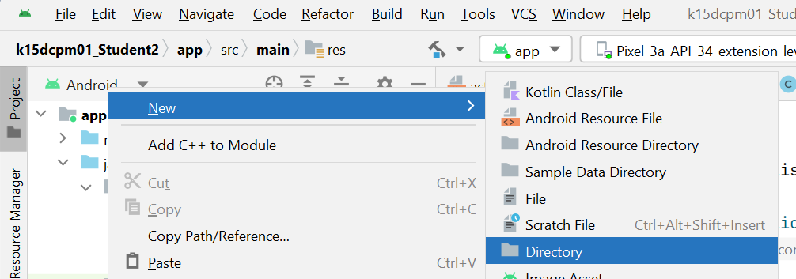

Trong thư mục “menu”, click New/Menu Resource File

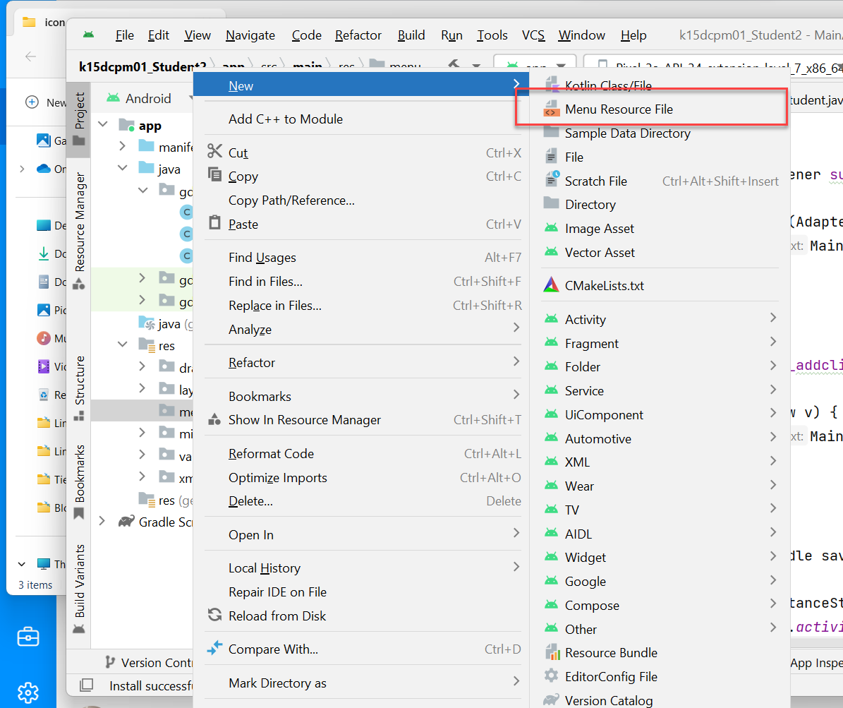

Design Menu như sau:

*<?*xml version="1.0" encoding="utf-8"*?>*<menu xmlns:android="http://schemas.android.com/apk/res/android"  
 xmlns:app="http://schemas.android.com/apk/res-auto">  
  
 <item android:id="@+id/mnu_ctxAdd"  
 android:title="Thêm sinh viên"  
 app:showAsAction="always"  
 android:orderInCategory="100"/>  
  
 <item android:id="@+id/mnu_ctxEdit"  
 android:title="Sửa"  
 app:showAsAction="always"  
 android:orderInCategory="100"/>  
  
 <item android:id="@+id/mnu_ctxDel"  
 android:title="Xóa"  
 app:showAsAction="always"  
 android:orderInCategory="100"/>  
  
</menu>

Trong Main Activity bổ sung 2 method sau

@Override  
public void onCreateContextMenu(ContextMenu menu, View v, ContextMenu.ContextMenuInfo menuInfo) {  
 super.onCreateContextMenu(menu, v, menuInfo);  
 getMenuInflater().inflate(R.menu.*context_menu*, menu);  
}  
  
@Override  
public boolean onContextItemSelected(@NonNull MenuItem item) {  
 AdapterView.AdapterContextMenuInfo info=(AdapterView.AdapterContextMenuInfo)item.getMenuInfo();  
 int pos=info.position;  
 int id=item.getItemId();  
 return super.onContextItemSelected(item);  
}

Trong oncreate cho thêm dòng

registerForContextMenu(lv_lststudents);

**Nâng cấp ContextMenu**

@Override  
public boolean onContextItemSelected(MenuItem item) {  
 AdapterView.AdapterContextMenuInfo info=(AdapterView.AdapterContextMenuInfo)item.getMenuInfo();  
 int pos=info.position;  
 int id=item.getItemId();  
 student=(Student)dssinhvien.get(pos);  
  
 if (id==R.id.*mnu_ctxEdit*)  
 {  
 DisplayStudent(student);  
 Editable(true);  
  
 }  
  
 else if (id==R.id.*mnu_ctxAdd*)  
 {  
 action=1;*/*Thêm mới*/* txtMaSV.setText("");  
 txtHoten.setText("");  
 txtClass.setText("");  
 txtAddress.setText("");  
 txtEmail.setText("");  
 rd_sex.check(rd_Male.getId());  
 Editable(true);  
 }  
  
 return super.onContextItemSelected(item);  
}

**NÂNG CẤP**

**Sử dụng Dialog**

Tạo Layout Resource File đặt tên là Student_edit

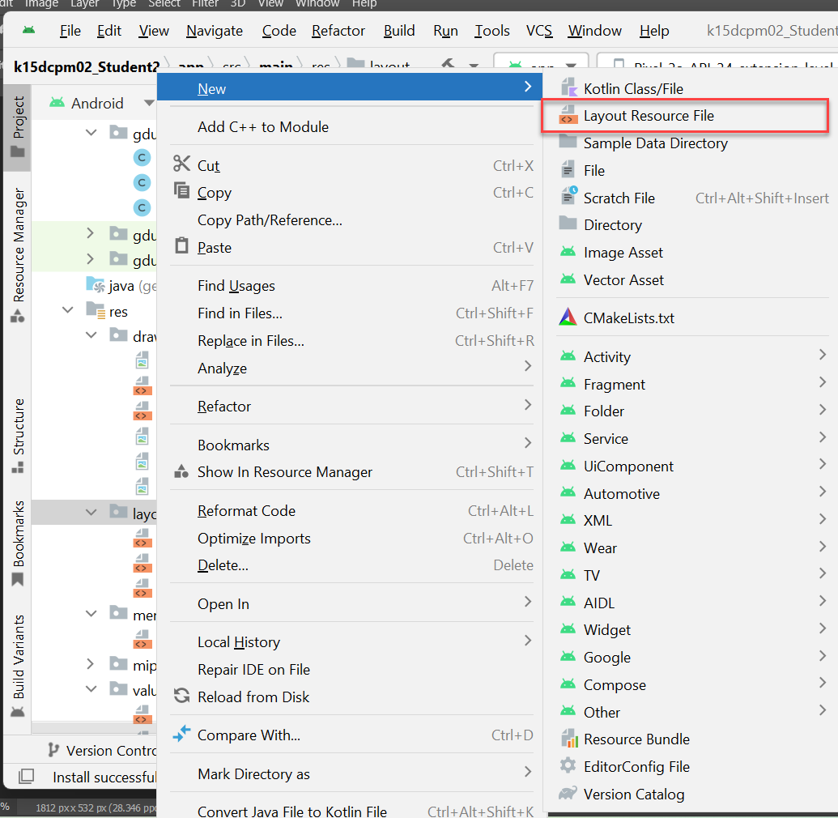

Layout của student_edit như sau:

*<?*xml version="1.0" encoding="utf-8"*?>*<LinearLayout xmlns:android="http://schemas.android.com/apk/res/android"  
 android:layout_width="match_parent"  
 android:layout_height="match_parent"  
 android:background="#77c7ec"  
 android:paddingLeft="3pt"  
 android:orientation="vertical">  
  
  
 <LinearLayout  
 android:layout_width="match_parent"  
 android:layout_height="match_parent"  
 android:paddingLeft="3dp"  
 android:orientation="vertical">  
  
  
 <LinearLayout  
 android:layout_width="match_parent"  
 android:layout_height="wrap_content"  
 android:orientation="horizontal">  
  
 <TextView  
 android:layout_width="45pt"  
 android:layout_height="wrap_content"  
 android:textSize="8pt"  
 android:text="Mã SV:"/>  
  
 <EditText  
 android:layout_width="wrap_content"  
 android:layout_height="wrap_content"  
 android:id="@+id/txtStudentNo"  
 android:textSize="8pt"  
 android:text=" "/>  
  
  
  
 </LinearLayout>  
  
 <LinearLayout  
 android:layout_width="match_parent"  
 android:layout_height="wrap_content"  
 android:orientation="horizontal">  
  
 <TextView  
 android:layout_width="45pt"  
 android:layout_height="wrap_content"  
 android:textSize="8pt"  
 android:text="Họ tên:"/>  
  
 <EditText  
 android:layout_width="wrap_content"  
 android:layout_height="wrap_content"  
 android:id="@+id/txtName"  
 android:textSize="8pt"  
 android:text=" "/>  
  
 </LinearLayout>  
  
 <LinearLayout  
 android:layout_width="match_parent"  
 android:layout_height="wrap_content"  
 android:orientation="horizontal">  
  
 <TextView  
 android:layout_width="45pt"  
 android:layout_height="wrap_content"  
 android:textSize="8pt"  
 android:text="Lớp:"/>  
  
 <EditText  
 android:layout_width="wrap_content"  
 android:layout_height="wrap_content"  
 android:id="@+id/txtClassNo"  
 android:textSize="8pt"  
 android:text=""/>  
  
 </LinearLayout>  
  
 <LinearLayout  
 android:layout_width="match_parent"  
 android:layout_height="wrap_content"  
 android:orientation="horizontal">  
  
 <TextView  
 android:layout_width="45pt"  
 android:layout_height="wrap_content"  
 android:textSize="8pt"  
 android:text="Địa chi:"/>  
  
 <EditText  
 android:layout_width="wrap_content"  
 android:layout_height="wrap_content"  
 android:id="@+id/txtAddress"  
 android:textSize="8pt"  
 android:text=""/>  
  
 </LinearLayout>  
  
 <LinearLayout  
 android:layout_width="match_parent"  
 android:layout_height="wrap_content"  
 android:orientation="horizontal">  
  
 <TextView  
 android:layout_width="45pt"  
 android:layout_height="wrap_content"  
 android:textSize="8pt"  
 android:text="Email:"/>  
  
 <EditText  
 android:layout_width="wrap_content"  
 android:layout_height="wrap_content"  
 android:id="@+id/txtEmail"  
 android:textSize="8pt"  
 android:text=""/>  
  
 </LinearLayout>  
  
 <LinearLayout  
 android:layout_width="match_parent"  
 android:layout_height="wrap_content"  
 android:orientation="horizontal">  
 <TextView  
 android:layout_width="wrap_content"  
 android:layout_height="wrap_content"  
 android:width="50pt"  
 android:textSize="8pt"  
 android:text="Nam/nữ:"  
 />  
 <RadioGroup  
 android:layout_width="wrap_content"  
 android:layout_height="wrap_content"  
 android:id="@+id/rd_sex"  
 android:orientation="horizontal">  
 <RadioButton  
 android:layout_width="wrap_content"  
 android:layout_height="wrap_content"  
 android:id="@+id/rd_Male"  
 android:checked="true"  
 android:text="Nam"/>  
  
 <RadioButton  
 android:layout_width="wrap_content"  
 android:layout_height="wrap_content"  
 android:id="@+id/rd_Famale"  
 android:text="Nữ"/>  
  
  
 </RadioGroup>  
  
  
  
 </LinearLayout>  
  
 </LinearLayout>  
  
  
</LinearLayout>

Trong MainActivity các bạn code thêm method Show_DialogSV như sau:

private void Show_DialogSV(Student sv, int option)  
{  
 AlertDialog.Builder buider=new AlertDialog.Builder(MainActivity.this);  
 LayoutInflater inflater=getLayoutInflater();  
 View alerlayout=inflater.inflate(R.layout.*student_edit*, null);  
 EditText txtStudentNo=(EditText) alerlayout.findViewById(R.id.*txtStudentNo*);  
 EditText txtName=(EditText) alerlayout.findViewById(R.id.*txtName*);  
 EditText txtClass=(EditText) alerlayout.findViewById(R.id.*txtClassNo*);  
 EditText txtAddress=(EditText) alerlayout.findViewById(R.id.*txtAddress*);  
 EditText txtEmail=(EditText) alerlayout.findViewById(R.id.*txtEmail*);  
 RadioButton rd_Male=(RadioButton) alerlayout.findViewById(R.id.*rd_Male*);  
 RadioButton rd_Famale=(RadioButton) alerlayout.findViewById(R.id.*rd_Famale*);  
 RadioGroup rd_sex=(RadioGroup) alerlayout.findViewById(R.id.*rd_sex*);  
 buider.setView(alerlayout);  
  
 if (option==1) */*Tạo mới*/* {  
 txtStudentNo.setText("");  
 txtName.setText("");  
 txtClass.setText("");  
 txtAddress.setText("");  
 txtEmail.setText("");  
 }  
 else if (option==2)*/*Sửa*/* {  
  
 txtStudentNo.setText(sv.getStudentNumber());  
 txtName.setText(sv.getFullName());  
 txtClass.setText(sv.getClassNo());  
 txtAddress.setText(sv.getAddress());  
 txtEmail.setText(sv.getEmail());  
 if (sv.isSex())  
 rd_sex.check(rd_Male.getId());  
 else  
 rd_sex.check(rd_Famale.getId());  
 }  
  
 buider.setTitle("Hiệu chỉnh");  
  
 buider.setPositiveButton("Ghi", new DialogInterface.OnClickListener() {  
 @Override  
 public void onClick(DialogInterface dialog, int which) {  
 Toast.*makeText*(MainActivity.this, "Ghi dữ liệu", Toast.*LENGTH_SHORT*).show();  
  
 }  
 });  
  
 buider.setNegativeButton("Hủy", new DialogInterface.OnClickListener() {  
 @Override  
 public void onClick(DialogInterface dialog, int which) {  
 dialog.dismiss();  
 }  
 });  
  
 buider.show();  
  
  
}

Sử dụng: Trong method onContextItemSelected sử dụng **Show_DialogSV**(student, thamso);

@Override  
public boolean onContextItemSelected(MenuItem item) {  
 AdapterView.AdapterContextMenuInfo info=(AdapterView.AdapterContextMenuInfo)item.getMenuInfo();  
 int pos=info.position;  
 int id=item.getItemId();  
 student=(Student)dssinhvien.get(pos);  
  
 if (id==R.id.*mnu_ctxEdit*)  
 {  
 Show_DialogSV(student,2);  
 }  
  
 else if (id==R.id.*mnu_ctxAdd*)  
 {  
 Show_DialogSV(student,1);  
 action=1;*/*Thêm mới*/* }  
  
 return super.onContextItemSelected(item);  
}

LÀM VIỆC VỚI CSDL SQLITE

Cần xây dựng class DBManager extends SQLiteOpenHelper

Các thủ tục chính:

* Constructor: Tạo luôn CSDL khi new DBManager

public DBManager(Context context)  
 {  
 super(context,"StudentDB",null,1);  
 this.context=context;  
 }

* Tạo mới các tables trong hàm oncreate

@Override  
 public void onCreate(SQLiteDatabase db)

* Xóa bảng rồi tạo mới csdl nếu nâng cấp ứng dụng  
    
  @Override  
   public void onUpgrade(SQLiteDatabase db, int oldVersion, int newVersion)
* Cú pháp của SQLite xem tại link: <https://www.tutorialspoint.com/sqlite/sqlite_syntax.htm>
* Sử dụng SQLite

<https://www.digitalocean.com/community/tutorials/android-sqlite-database-example-tutorial>

Code mẫu như sau:

package gdu.edu.k15dcpm06_student2;  
  
import android.content.ContentValues;  
import android.content.Context;  
import android.database.Cursor;  
import android.database.sqlite.SQLiteDatabase;  
import android.database.sqlite.SQLiteOpenHelper;  
import android.widget.Toast;  
  
import java.util.ArrayList;  
  
  
public class DBManager extends SQLiteOpenHelper  
{  
 String DB_NAME="StudentDB";  
 private String TABLE_NAME="Student";  
 private Context context;  
  
 *//Constructor đồng thời tạo DB* public DBManager(Context context)  
 {  
 super(context,"StudentDB",null,1);  
 this.context=context;  
 }  
  
 *//Tạo các table trong CSDL* @Override  
 public void onCreate(SQLiteDatabase db)  
 {  
 String sql="CREATE TABLE Student(id integer primary key autoincrement,"  
 +"studentNumber nvarchar(50),fullName nvarchar(200), classNo nvarchar(50), "  
 +" address nvarchar(300), email varchar(100), sex boolean) ";  
 db.execSQL(sql);  
 Toast.*makeText*(context, "Đã tạo xong Table trong CSDL", Toast.*LENGTH_SHORT*).show();  
 }  
  
 *//Tạo CSDL lúc update phiên bản* @Override  
 public void onUpgrade(SQLiteDatabase db, int oldVersion, int newVersion)  
 {  
 String sql="DROP TABLE IF EXISTS "+TABLE_NAME;  
 db.execSQL(sql);  
 onCreate(db);  
 }  
  
 public void AddStudents(ArrayList<Student> lst)  
 {  
 for (int i=0;i<lst.size();i++)  
 {  
 Student sv=lst.get(i);  
 AddStudent(sv);  
  
 }  
  
 }  
 public boolean AddStudent(Student sv)  
 {  
 long kq=0;  
 try {  
 SQLiteDatabase db=this.getWritableDatabase();  
 ContentValues prams=new ContentValues();  
 prams.put("studentNumber",sv.getStudentNumber());  
 prams.put("fullName",sv.getFullName());  
 prams.put("classNo",sv.getClassNo());  
 prams.put("address",sv.getAddress());  
 prams.put("email",sv.getEmail());  
 prams.put("sex",sv.isSex());  
  
 kq = db.insert(TABLE_NAME, null, prams);  
 db.close();  
 }catch (Exception ex)  
 {  
 Toast.*makeText*(context, ex.getMessage(), Toast.*LENGTH_SHORT*).show();  
 }  
 return kq>0;  
 }  
  
 public boolean EditStudent(Student sv)  
 {  
 SQLiteDatabase db=this.getWritableDatabase();  
 ContentValues prams=new ContentValues();  
 prams.put("studentNumber",sv.getStudentNumber());  
 prams.put("fullName",sv.getFullName());  
 prams.put("classNo",sv.getClassNo());  
 prams.put("address",sv.getAddress());  
 prams.put("email",sv.getEmail());  
 prams.put("sex",sv.isSex());  
  
 long kq=db.update(TABLE_NAME,prams,"id=?",new String[]{ String.*valueOf*(sv.getId())});  
 db.close();  
 return kq>0;  
 }  
  
 public ArrayList<Student> ListStudents()  
 {  
 ArrayList<Student> lst=new ArrayList<>();  
 SQLiteDatabase db=this.getWritableDatabase();  
 String sql="SELECT id, studentNumber,fullName,classNo,address,email,sex FROM "+TABLE_NAME;  
 Cursor rs=db.rawQuery(sql,null);  
 if (rs.moveToFirst())  
 {  
 do {  
 Student sv=new Student();  
 sv.setId(rs.getInt(0));  
 sv.setStudentNumber(rs.getString(1));  
 sv.setFullName(rs.getString(2));  
 sv.setClassNo(rs.getString(3));  
 sv.setAddress(rs.getString(4));  
 sv.setEmail(rs.getString(5));  
 sv.setSex(rs.getInt(6)==1);  
 lst.add(sv);  
  
 }while (rs.moveToNext());  
 }  
  
 rs.close();  
 db.close();  
  
 return lst;  
 }  
  
  
  
  
}

Trong onCreate của MainActivity, bổ sung thêm mấy dòng code:

dssinhvien=Student.*gen_random_student*(100);  
dbmanager=new DBManager(this);  
dbmanager.AddStudents(dssinhvien);  
dssinhvien=dbmanager.ListStudents();

Chạy lần đầu tiên rồi comment dòng lệnh tạo sinh viên lại

*//dssinhvien=Student.gen_random_student(100);*

Trong thủ tục Ghi trong Dialog, bổ sung thêm đoạn code:

sv.setStudentNumber(txtStudentNo.getText().toString());  
sv.setFullName(txtName.getText().toString());  
sv.setAddress(txtAddress.getText().toString());  
sv.setClassNo(txtClass.getText().toString());  
sv.setEmail(txtEmail.getText().toString());  
sv.setSex(rd_Male.isChecked());  
if (option==1)  
 dbmanager.AddStudent(sv);*//Thêm mới vào CSDL*else if (option==2)  
dbmanager.EditStudent(sv);*//Cập nhật vào CSDL*myadapter.notifyDataSetChanged();

KẾT NỐI BACKEND

* API để test: https://fakestoreapi.com/products/
* Các thư viện để sử dụng:

Vào File/Project Structure…

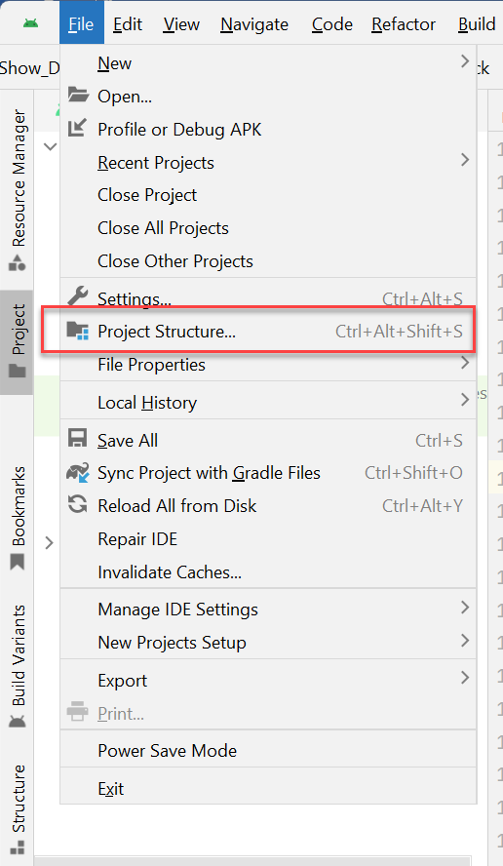

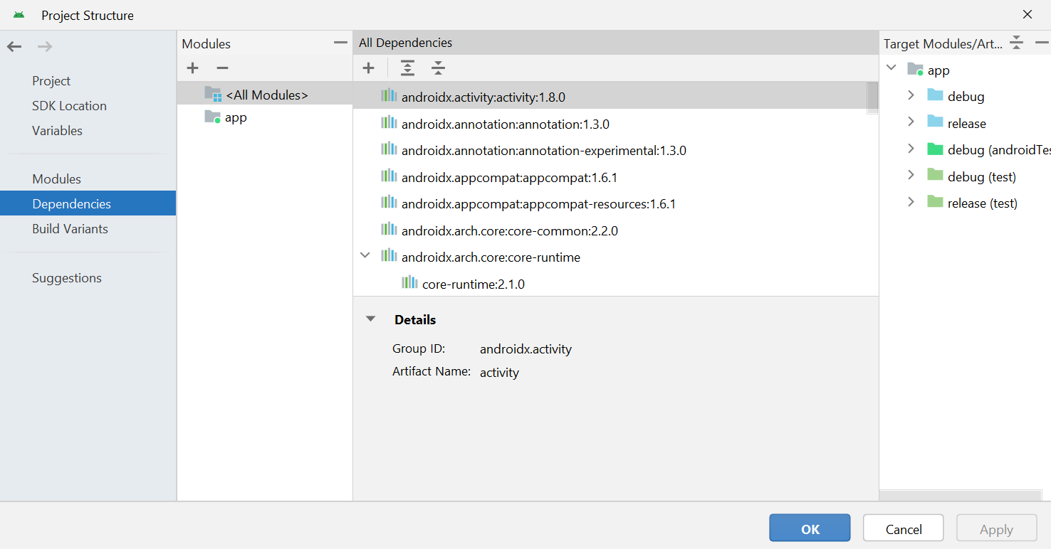

+ Thư viện: OkHttp3 sử dụng để kết nối web

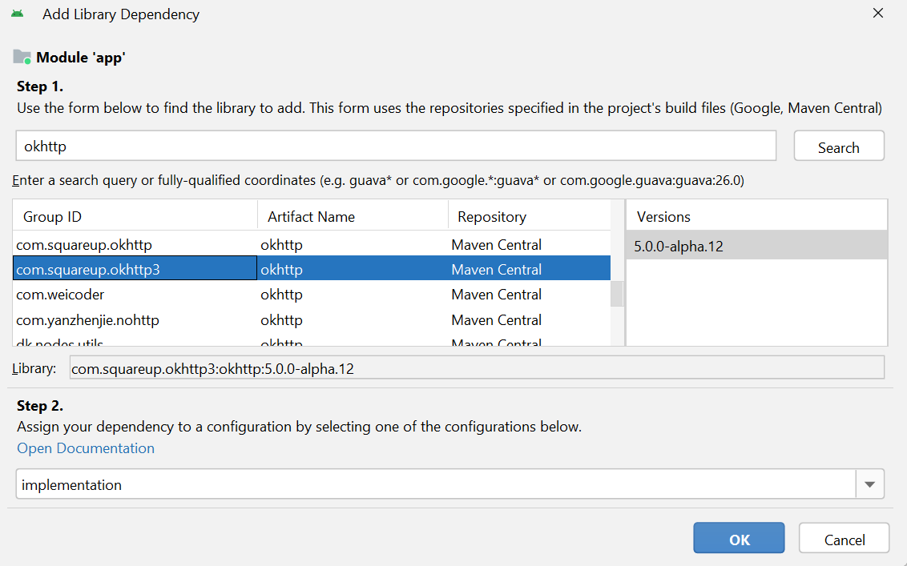

+ Thư viện Moshi để xử lý JSON

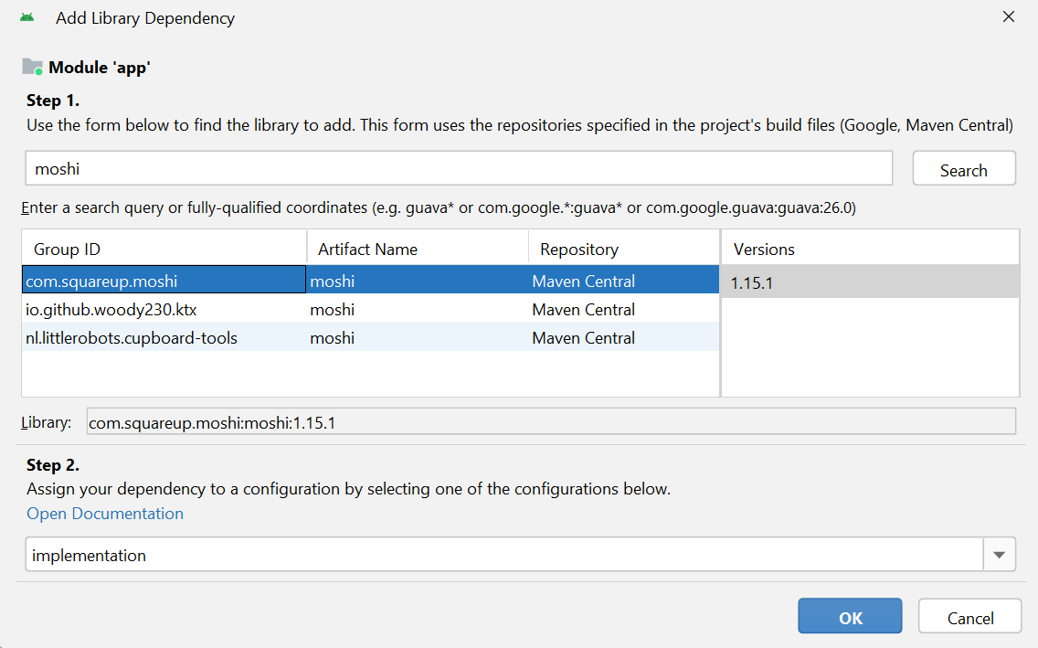

+ Thư viện Picasso để xử lý ảnh

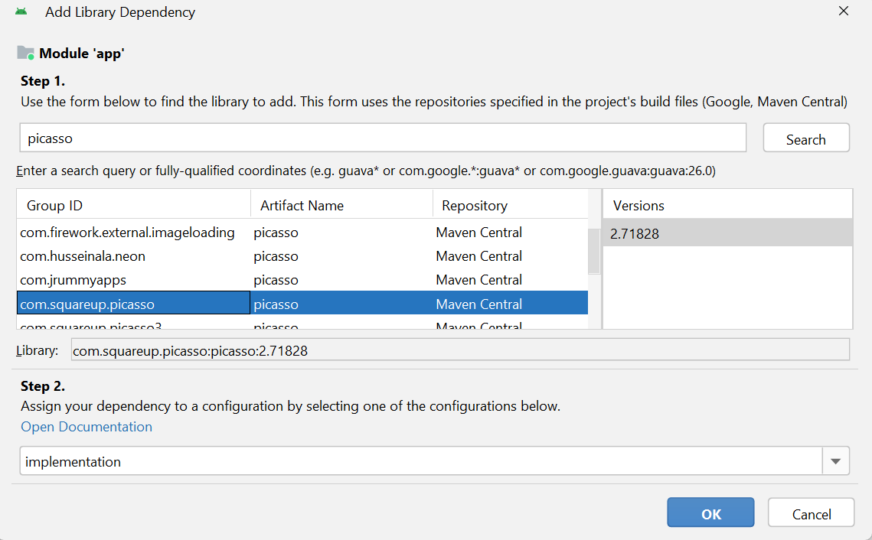

Cấu hình Quyền truy cập Internet cho ứng dụng

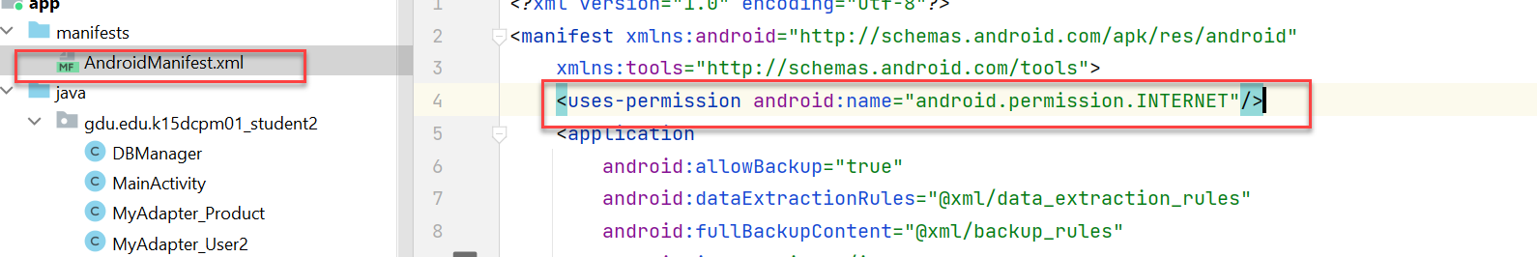

Thiết kế Layout “item_listproduct” cho item product

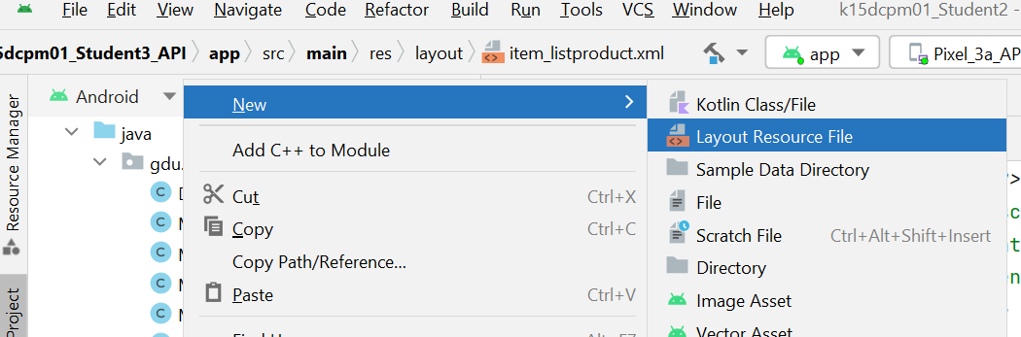

*<?*xml version="1.0" encoding="utf-8"*?>*<LinearLayout xmlns:android="http://schemas.android.com/apk/res/android"  
 android:layout_width="match_parent"  
 android:layout_height="wrap_content"  
 android:orientation="horizontal">  
  
 <ImageView  
 android:layout_width="80dp"  
 android:layout_height="120dp"  
 android:src="@drawable/man"  
 android:id="@+id/iv_avatar"/>  
  
 <LinearLayout  
 android:layout_width="wrap_content"  
 android:layout_height="wrap_content"  
 android:orientation="vertical"  
 android:layout_marginLeft="5dp">  
  
 <TextView  
 android:layout_width="wrap_content"  
 android:layout_height="wrap_content"  
 android:id="@+id/txtTitle"  
 android:text="Bphone siêu hạng"  
 android:textSize="12dp"  
 android:textStyle="bold"/>  
 <TextView  
 android:layout_width="wrap_content"  
 android:layout_height="wrap_content"  
 android:id="@+id/txtCategory"  
 android:text="Category: Điện thoại"/>  
  
 <TextView  
 android:layout_width="wrap_content"  
 android:layout_height="wrap_content"  
 android:id="@+id/txtPrice"  
 android:text="Giá: 15 củ"/>  
  
 <TextView  
 android:layout_width="wrap_content"  
 android:layout_height="wrap_content"  
 android:id="@+id/txtDescription"  
  
 android:text="Sản phẩm trứ danh số 1 Việt Nam, do Kỹ su VN nghiên cứu chế tạo"/>  
  
  
 </LinearLayout>  
  
</LinearLayout>

+ Tạo Model Product như sau:

package gdu.edu.k15dcpm01_student2;  
  
public class Product  
{  
 private int id;  
 private String title;  
  
 private double price;  
 private String description;  
 private String category;  
 private String image;  
  
 public int getId() {  
 return id;  
 }  
  
 public void setId(int id) {  
 this.id = id;  
 }  
  
 public String getTitle() {  
 return title;  
 }  
  
 public void setTitle(String title) {  
 this.title = title;  
 }  
  
 public double getPrice() {  
 return price;  
 }  
  
 public void setPrice(double price) {  
 this.price = price;  
 }  
  
 public String getDescription() {  
 return description;  
 }  
  
 public void setDescription(String description) {  
 this.description = description;  
 }  
  
 public String getCategory() {  
 return category;  
 }  
  
 public void setCategory(String category) {  
 this.category = category;  
 }  
  
 public String getImage() {  
 return image;  
 }  
  
 public void setImage(String image) {  
 this.image = image;  
 }  
}

+ Thiết kế class MyAdapter_Product để đổ dữ liệu

package gdu.edu.k15dcpm01_student2;  
  
import android.app.Activity;  
import android.content.Context;  
import android.view.LayoutInflater;  
import android.view.View;  
import android.view.ViewGroup;  
import android.widget.ArrayAdapter;  
import android.widget.ImageView;  
import android.widget.TextView;  
import android.widget.Toast;  
  
  
import com.squareup.picasso.*;  
  
import java.util.ArrayList;  
  
public class MyAdapter_Product extends ArrayAdapter<Product>  
{  
 private Context context;*/* Activity (tức là Form) cần xử lý */* private int resource;*/* File resouce item_listview mà mình định custom */* private ArrayList<Product> dssanpham; */*List sv*/* public MyAdapter_Product(Context context, int resource, ArrayList<Product> dssanpham)  
 {  
 super(context,resource,dssanpham);  
 this.context=context;  
 this.resource=resource;  
 this.dssanpham=dssanpham;  
 }  
  
  
  
 @Override  
 public View getView(int position, View current, ViewGroup parent) {  
 MyAdapter_Product.ViewHolder_Product viewholder;  
  
 if (current==null)  
 {  
 current= LayoutInflater.*from*(context).inflate(resource,parent,false);  
 viewholder=new MyAdapter_Product.ViewHolder_Product();  
 viewholder.iv_avatar=(ImageView) current.findViewById(R.id.*iv_avatar*);  
 viewholder.txtTitle=(TextView) current.findViewById(R.id.*txtTitle*);  
 viewholder.txtCategory=(TextView) current.findViewById(R.id.*txtCategory*);  
 viewholder.txtPrice=(TextView) current.findViewById(R.id.*txtPrice*);  
 viewholder.txtDescription=(TextView) current.findViewById(R.id.*txtDescription*);  
  
 *//Lưu lại viewholder* current.setTag(viewholder);  
 }  
 else  
 {  
 viewholder=(MyAdapter_Product.ViewHolder_Product) current.getTag();  
 }  
  
 try {  
 Product product = dssanpham.get(position);  
 viewholder.txtTitle.setText(product.getTitle());  
 viewholder.txtCategory.setText(product.getCategory());  
 viewholder.txtPrice.setText(product.getPrice() + "");  
 viewholder.txtDescription.setText(product.getDescription());  
  
 Picasso.*get*()  
 .load(product.getImage())  
 .into(viewholder.iv_avatar);  
  
 }catch (Exception ex)  
 {  
 *//System.out.println(ex.getMessage());  
 //Toast.makeText(context, ex.getMessage(),Toast.LENGTH_SHORT).show();* }  
 return current;  
 };  
  
  
  
 public class ViewHolder_Product  
 {  
 ImageView iv_avatar;  
 TextView txtTitle,txtCategory,txtPrice,txtDescription;  
 }  
  
}

* Thiết kế activity_main.xml

*<?*xml version="1.0" encoding="utf-8"*?>*<LinearLayout xmlns:android="http://schemas.android.com/apk/res/android"  
 xmlns:app="http://schemas.android.com/apk/res-auto"  
 xmlns:tools="http://schemas.android.com/tools"  
 android:layout_width="match_parent"  
 android:layout_height="match_parent"  
 android:orientation="vertical"  
 tools:context=".MainActivity">  
  
 <LinearLayout  
 android:layout_width="match_parent"  
 android:layout_height="wrap_content"  
 android:orientation="horizontal">  
  
 <ImageView  
 android:layout_width="wrap_content"  
 android:layout_height="wrap_content"  
 android:layout_gravity="center"  
 android:src="@drawable/logo"  
 />  
  
 <TextView  
 android:layout_width="wrap_content"  
 android:layout_height="wrap_content"  
 android:layout_gravity="center"  
 android:paddingLeft="5dp"  
 android:text=" STORE\n MANAGEMENT"  
 android:textColor="@color/design_default_color_primary"  
 android:textSize="9pt"  
 android:textStyle="bold" />  
  
 </LinearLayout>  
  
 <GridView  
 android:layout_width="match_parent"  
 android:layout_height="match_parent"  
 android:numColumns="2"  
 android:background="@drawable/ic_launcher_foreground"  
 android:id="@+id/grid1"  
 />  
  
  
  
</LinearLayout>

Vào MainActivity viết code cho thủ tục ListProductFromAPI như sau:

private void ListProductFromAPI(String url_string)  
{  
 OkHttpClient client = new OkHttpClient();  
  
 Request request=new Request.Builder().url(url_string).build();  
 client.newCall(request).enqueue(new okhttp3.Callback() {  
 @Override  
 public void onFailure(@NonNull Call call, @NonNull IOException e) {  
 Log.*e*("Error", "Network error");  
 }  
  
 @Override  
 public void onResponse(@NonNull Call call, @NonNull Response response) throws IOException {  
 String json=response.body().string();  
 *//Toast.makeText(MainActivity.this,json,Toast.LENGTH_LONG).show();* Moshi moshi=new Moshi.Builder().build();  
 Type usertype= Types.*newParameterizedType*(List.class,Product.class);  
 JsonAdapter<List<Product>> jsonadapter=moshi.adapter(usertype);  
 final List<Product> products=jsonadapter.fromJson(json);  
 ds_products=new ArrayList<>(products);  
 runOnUiThread(new Runnable() {  
 @Override  
 public void run() {  
  
 myadapter=new MyAdapter_Product(MainActivity.this,R.layout.*item_listproduct*,ds_products);  
 grid1.setAdapter(myadapter);  
 }  
 });  
 }  
 });  
}

//-----------Phần import

import androidx.annotation.NonNull;  
import androidx.appcompat.app.AlertDialog;  
import androidx.appcompat.app.AppCompatActivity;  
  
import android.content.DialogInterface;  
import android.os.Bundle;  
import android.util.Log;  
import android.view.ContextMenu;  
import android.view.LayoutInflater;  
import android.view.MenuItem;  
import android.view.View;  
import android.widget.AdapterView;  
import android.widget.EditText;  
import android.widget.GridView;  
import android.widget.RadioButton;  
import android.widget.RadioGroup;  
import android.widget.Toast;  
  
import com.squareup.moshi.JsonAdapter;  
import com.squareup.moshi.Moshi;  
import com.squareup.moshi.Types;  
  
import org.json.JSONException;  
import org.json.JSONObject;  
  
import java.io.IOException;  
import java.lang.reflect.Type;  
import java.util.ArrayList;  
import java.util.List;  
  
import okhttp3.Call;  
import okhttp3.Callback;  
import okhttp3.MediaType;  
import okhttp3.OkHttpClient;  
import okhttp3.Request;  
import okhttp3.RequestBody;  
import okhttp3.Response;

//--------------OnCreate

…..

grid1=(GridView) findViewById(R.id.*grid1*);  
ListProductFromAPI("https://fakestoreapi.com/products");

**Nâng cấp thêm**

Làm thêm menu

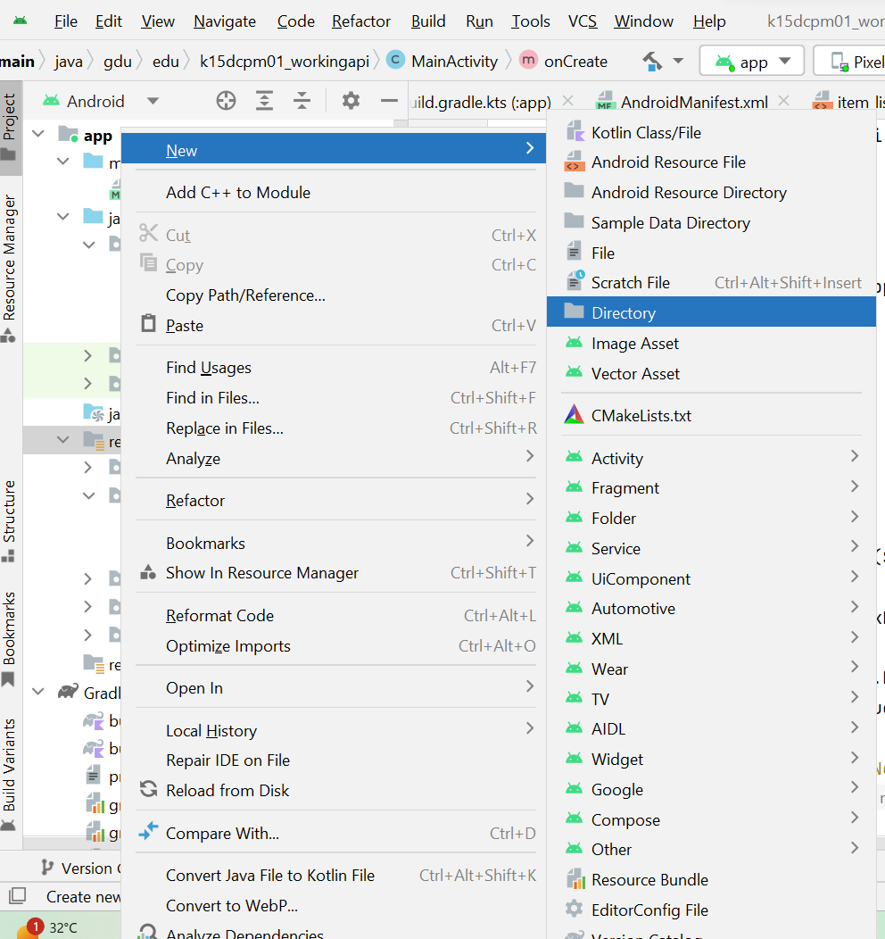

Và tạo thư mục menu

Trong thư mục menu tạo menu layout:

*<?*xml version="1.0" encoding="utf-8"*?>*<menu xmlns:android="http://schemas.android.com/apk/res/android"  
 xmlns:app="http://schemas.android.com/apk/res-auto">  
  
 <item android:id="@+id/mnu_ctxAdd"  
 android:title="Add product"  
 app:showAsAction="always"  
 android:orderInCategory="100"/>  
  
 <item android:id="@+id/mnu_ctxEdit"  
 android:title="Modify product"  
 app:showAsAction="always"  
 android:orderInCategory="100"/>  
  
 <item android:id="@+id/mnu_ctxDel"  
 android:title="Exit"  
 app:showAsAction="always"  
 android:orderInCategory="100"/>  
  
</menu>

Trong thư mục layout tạo thêm file layout resource có tên “edit_layout”:

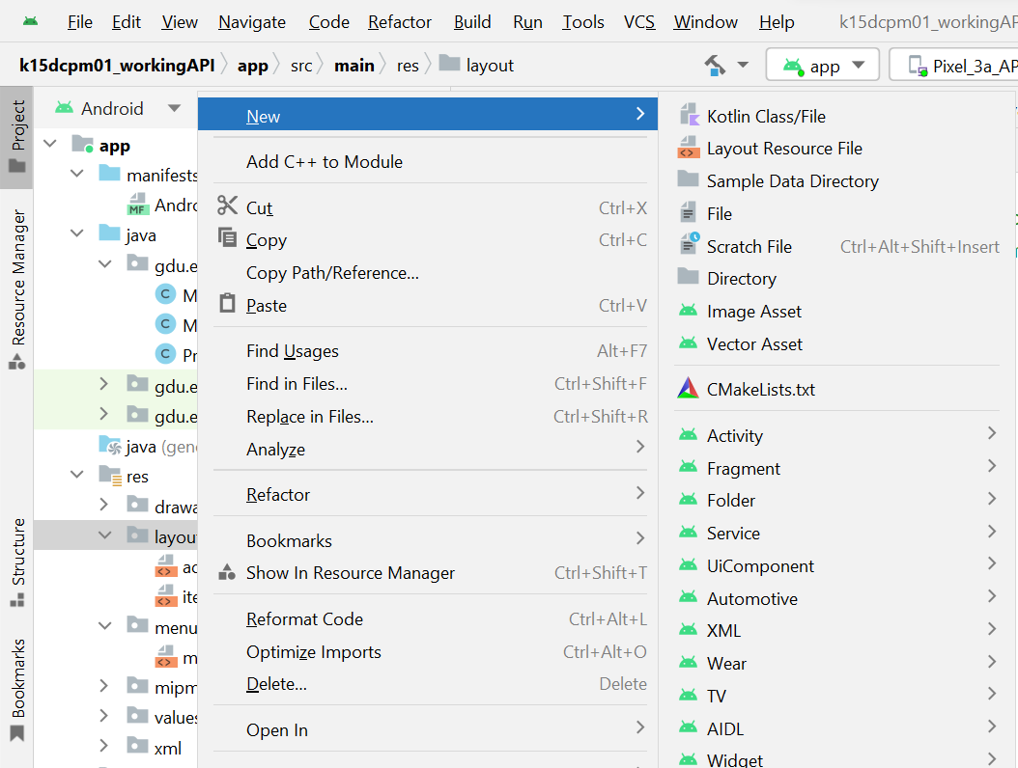

*<?*xml version="1.0" encoding="utf-8"*?>*<LinearLayout xmlns:android="http://schemas.android.com/apk/res/android"  
 android:layout_width="match_parent"  
 android:layout_height="match_parent"  
 android:background="#77c7ec"  
 android:paddingLeft="3pt"  
 android:orientation="vertical">  
  
  
 <LinearLayout  
 android:layout_width="match_parent"  
 android:layout_height="match_parent"  
 android:paddingLeft="3dp"  
 android:orientation="vertical">  
  
  
 <LinearLayout  
 android:layout_width="match_parent"  
 android:layout_height="wrap_content"  
 android:orientation="horizontal">  
  
 <TextView  
 android:layout_width="45pt"  
 android:layout_height="wrap_content"  
 android:textSize="8pt"  
 android:text="Title:"/>  
  
 <EditText  
 android:layout_width="wrap_content"  
 android:layout_height="wrap_content"  
 android:id="@+id/txt_title"  
 android:textSize="8pt"  
 android:text=" "/>  
  
  
  
 </LinearLayout>  
  
 <LinearLayout  
 android:layout_width="match_parent"  
 android:layout_height="wrap_content"  
 android:orientation="horizontal">  
  
 <TextView  
 android:layout_width="45pt"  
 android:layout_height="wrap_content"  
 android:textSize="8pt"  
 android:text="Price:"/>  
  
 <EditText  
 android:layout_width="wrap_content"  
 android:layout_height="wrap_content"  
 android:id="@+id/txt_price"  
 android:textSize="8pt"  
 android:text=" "/>  
  
 </LinearLayout>  
  
 <LinearLayout  
 android:layout_width="match_parent"  
 android:layout_height="wrap_content"  
 android:orientation="horizontal">  
  
 <TextView  
 android:layout_width="45pt"  
 android:layout_height="wrap_content"  
 android:textSize="8pt"  
 android:text="Description:"/>  
  
 <EditText  
 android:layout_width="wrap_content"  
 android:layout_height="wrap_content"  
 android:id="@+id/txt_description"  
 android:textSize="8pt"  
 android:text=""/>  
  
 </LinearLayout>  
  
 <LinearLayout  
 android:layout_width="match_parent"  
 android:layout_height="wrap_content"  
 android:orientation="horizontal">  
  
 <TextView  
 android:layout_width="45pt"  
 android:layout_height="wrap_content"  
 android:textSize="8pt"  
 android:text="Category:"/>  
  
 <EditText  
 android:layout_width="wrap_content"  
 android:layout_height="wrap_content"  
 android:id="@+id/txt_category"  
 android:textSize="8pt"  
 android:text=""/>  
  
 </LinearLayout>  
  
 <LinearLayout  
 android:layout_width="match_parent"  
 android:layout_height="wrap_content"  
 android:orientation="horizontal">  
  
 <TextView  
 android:layout_width="45pt"  
 android:layout_height="wrap_content"  
 android:textSize="8pt"  
 android:text="Image:"/>  
  
 <EditText  
 android:layout_width="wrap_content"  
 android:layout_height="wrap_content"  
 android:id="@+id/txt_image"  
 android:textSize="8pt"  
 android:text=""/>  
  
 </LinearLayout>  
  
  
 </LinearLayout>  
  
  
</LinearLayout>

Vào MainActivity thêm các method sau:

private void Show_DialogSV(Product product, int option)  
{  
 AlertDialog.Builder buider=new AlertDialog.Builder(MainActivity.this);  
 LayoutInflater inflater=getLayoutInflater();  
 View alerlayout=inflater.inflate(R.layout.*edit_layout*, null);  
 EditText txt_title=(EditText) alerlayout.findViewById(R.id.*txt_title*);  
 EditText txt_price=(EditText) alerlayout.findViewById(R.id.*txt_price*);  
 EditText txt_description=(EditText) alerlayout.findViewById(R.id.*txt_description*);  
 EditText txt_category=(EditText) alerlayout.findViewById(R.id.*txt_category*);  
 EditText txt_image=(EditText) alerlayout.findViewById(R.id.*txt_image*);  
  
 buider.setView(alerlayout);  
  
 if (option==1) */*Tạo mới*/* {  
 txt_title.setText("");  
 txt_price.setText("");  
 txt_description.setText("");  
 txt_category.setText("");  
 txt_image.setText("");  
 }  
 else if (option==2)*/*Sửa*/* {  
  
 txt_title.setText(product.getTitle());  
 txt_price.setText(product.getPrice()+"");  
 txt_description.setText(product.getDescription());  
 txt_category.setText(product.getCategory());  
 txt_image.setText(product.getImage());  
  
 }  
  
 buider.setTitle("Hiệu chỉnh");  
  
 buider.setPositiveButton("Ghi", new DialogInterface.OnClickListener() {  
 @Override  
 public void onClick(DialogInterface dialog, int which) {  
  
 product.setTitle(txt_title.getText().toString());  
 double price=Double.*valueOf*(txt_price.getText().toString());  
 product.setPrice(price);  
 product.setDescription(txt_description.getText().toString());  
 product.setCategory(txt_category.getText().toString());  
 product.setImage(txt_image.getText().toString());  
  
 if (option==2)  
 {  
 *//UpdateAPI("https://fakestoreapi.com/products/"+product.getId(),product);* }  
  
 *//Cập nhật vào backend* myadapter.notifyDataSetChanged();  
  
  
 Toast.*makeText*(MainActivity.this, "Ghi dữ liệu", Toast.*LENGTH_SHORT*).show();  
  
 }  
 });  
  
 buider.setNegativeButton("Hủy", new DialogInterface.OnClickListener() {  
 @Override  
 public void onClick(DialogInterface dialog, int which) {  
 dialog.dismiss();  
 }  
 });  
  
 buider.show();  
  
  
}  
  
  
@Override  
public void onCreateContextMenu(ContextMenu menu, View v, ContextMenu.ContextMenuInfo menuInfo) {  
 super.onCreateContextMenu(menu, v, menuInfo);  
 getMenuInflater().inflate(R.menu.*menu_context*, menu);  
}  
  
@Override  
public boolean onContextItemSelected(MenuItem item) {  
 AdapterView.AdapterContextMenuInfo info=(AdapterView.AdapterContextMenuInfo)item.getMenuInfo();  
 int pos=info.position;  
 int id=item.getItemId();  
 product=(Product) ds_products.get(pos);  
  
 if (id==R.id.*mnu_ctxEdit*)  
 {  
 Show_DialogSV(product,2);  
 }  
  
 else if (id==R.id.*mnu_ctxAdd*)  
 {  
 Show_DialogSV(product,1);  
 *//action=1;/*Thêm mới*/* }  
  
 return super.onContextItemSelected(item);  
}

Trong thủ tục onCreate thêm câu lệnh:

registerForContextMenu(grid1);

Thủ tục Update mục vào API:

public static final MediaType *JSON* = MediaType.*get*("application/json; charset=utf-8");

public void UpdateAPI(String url_string, Product product) throws IOException {  
  
 MediaType MEDIA_TYPE = MediaType.*parse*("application/json");  
  
 OkHttpClient client = new OkHttpClient();  
 JSONObject postdata = new JSONObject();  
 try {  
 postdata.put("title", product.getTitle());  
 postdata.put("price", String.*valueOf*(product.getPrice()));  
 postdata.put("category", product.getCategory());  
 postdata.put("description", product.getDescription());  
 postdata.put("image", product.getImage());  
 } catch(JSONException e){  
 *// TODO Auto-generated catch block* e.printStackTrace();  
 }  
  
 RequestBody body = RequestBody.*Companion*.create(postdata.toString(), *JSON*);  
 Request request = new Request.Builder()  
 .url(url_string)  
 .put(body)  
*// .header("Accept", "application/json")  
// .header("Content-Type", "application/json")* .build();  
  
 client.newCall(request).enqueue(new Callback() {  
 @Override  
 public void onFailure(Call call, IOException e)  
 {  
  
 String mMessage = e.getMessage().toString();  
 Log.*w*("failure Response", mMessage);  
 *//call.cancel();* }  
  
 @Override  
 public void onResponse(Call call, Response response) throws IOException {  
  
 String mMessage = response.body().string();  
  
 Log.*w*("json response",mMessage);  
 Log.*w*("all message",response.toString());  
  
 }  
 });  
 }

Trong thủ tục Ghi

if (option==2)  
{  
 try {  
 UpdateAPI("https://fakestoreapi.com/products/" + product.getId(), product);  
 myadapter.notifyDataSetChanged();  
 }catch (Exception ex)  
 {  
 Toast.*makeText*(MainActivity.this, "Lỗi:"+ex.getMessage(), Toast.*LENGTH_SHORT*).show();  
 }  
  
}

Chú ý xem Log để biết tình trạng

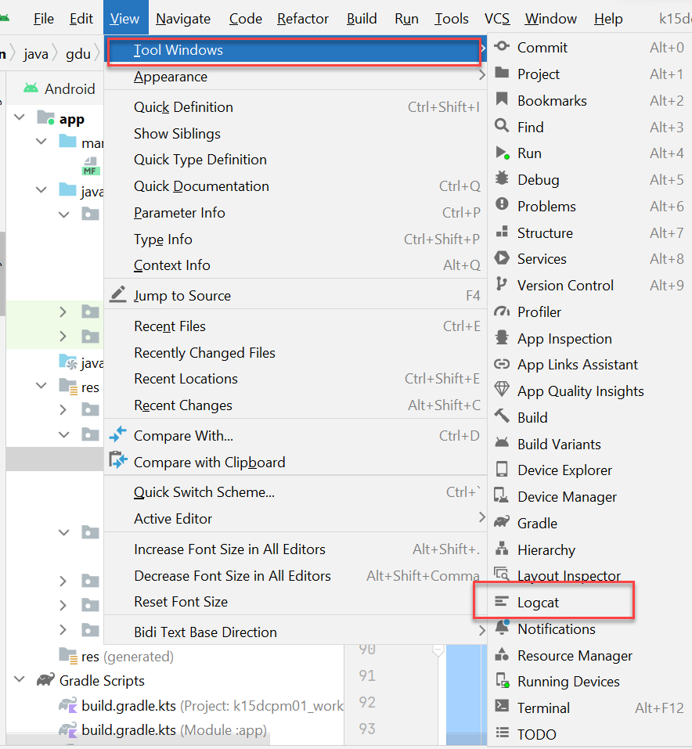

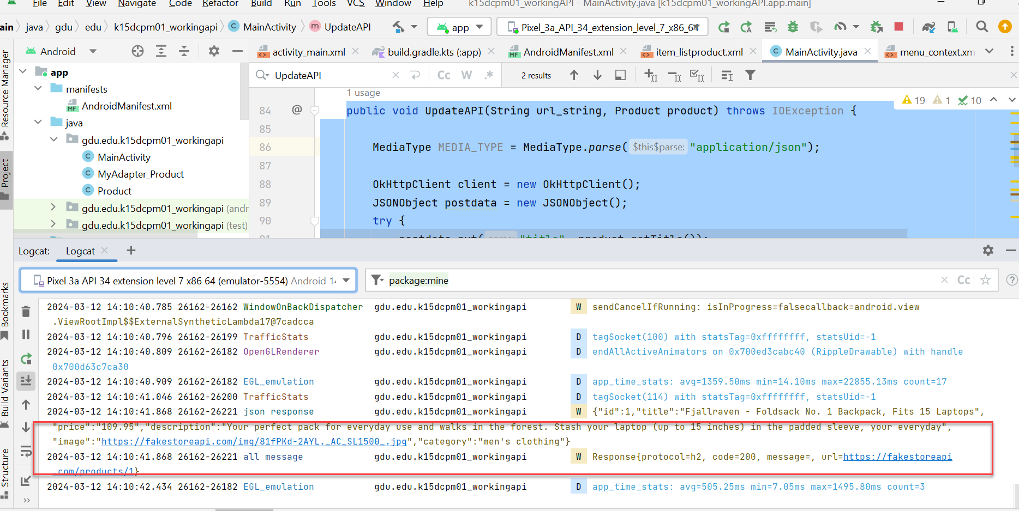

Viết thủ tục INSERT DỮ LIỆU GỬI CHO RESFULTAPI

public void InsertAPI(String url_string, Product product) throws IOException {  
  
 MediaType MEDIA_TYPE = MediaType.*parse*("application/json");  
  
 OkHttpClient client = new OkHttpClient();  
 JSONObject postdata = new JSONObject();  
 try {  
 postdata.put("title", product.getTitle());  
 postdata.put("price", String.*valueOf*(product.getPrice()));  
 postdata.put("category", product.getCategory());  
 postdata.put("description", product.getDescription());  
 postdata.put("image", product.getImage());  
 } catch(JSONException e){  
 *// TODO Auto-generated catch block* e.printStackTrace();  
 }  
  
 RequestBody body = RequestBody.*Companion*.create(postdata.toString(), *JSON*);  
 Request request = new Request.Builder()  
 .url(url_string)  
 .post(body)  
 .build();  
  
 client.newCall(request).enqueue(new Callback() {  
 @Override  
 public void onFailure(Call call, IOException e)  
 {  
  
 String mMessage = e.getMessage().toString();  
 Log.*w*("failure Response", mMessage);  
 *//call.cancel();* }  
  
 @Override  
 public void onResponse(Call call, Response response) throws IOException {  
  
 String mMessage = response.body().string();  
  
 Log.*w*("json response",mMessage);  
 Log.*w*("all message",response.toString());  
  
 }  
 });  
}

Thủ tục DELETE mục dữ liệu kết nối với backend

public void DelteteAPI(String url_string) throws IOException {  
  
 OkHttpClient client = new OkHttpClient();  
 Request request = new Request.Builder()  
 .url(url_string)  
 .delete()  
 .build();  
  
 client.newCall(request).enqueue(new Callback() {  
 @Override  
 public void onFailure(Call call, IOException e)  
 {  
  
 String mMessage = e.getMessage().toString();  
 Log.*w*("Delete failure Response", mMessage);  
 *//call.cancel();* }  
  
 @Override  
 public void onResponse(Call call, Response response) throws IOException {  
  
 String mMessage = response.body().string();  
  
 Log.*w*("Delete json response",mMessage);  
 Log.*w*("Delete all message",response.toString());  
  
 }  
 });  
}

* Viết lại sự kiện menu

@Override  
public boolean onContextItemSelected(MenuItem item) {  
 AdapterView.AdapterContextMenuInfo info=(AdapterView.AdapterContextMenuInfo)item.getMenuInfo();  
 int pos=info.position;  
 int id=item.getItemId();  
 product=(Product) ds_products.get(pos);  
  
 if (id==R.id.*mnu_ctxEdit*)  
 {  
 Show_DialogSV(product,2);  
 }  
  
 else if (id==R.id.*mnu_ctxAdd*)  
 {  
 Show_DialogSV(product,1);  
 *//action=1;/*Thêm mới*/* }  
 else if (id==R.id.*mnu_ctxDel*)  
 {  
 try {  
 DelteteAPI("https://fakestoreapi.com/products/" + String.*valueOf*(product.getId()));  
 ds_products.remove(product);  
 myadapter.notifyDataSetChanged();  
 }catch (Exception ex)  
 {}  
  
 }  
  
 return super.onContextItemSelected(item);  
}

Sửa lại nút ghi trong Dialog

buider.setPositiveButton("Ghi", new DialogInterface.OnClickListener() {  
 @Override  
 public void onClick(DialogInterface dialog, int which) {  
  
 product.setTitle(txt_title.getText().toString());  
 double price=Double.*valueOf*(txt_price.getText().toString());  
 product.setPrice(price);  
 product.setDescription(txt_description.getText().toString());  
 product.setCategory(txt_category.getText().toString());  
 product.setImage(txt_image.getText().toString());  
  
 if (option==2)  
 {  
 try {  
 UpdateAPI("https://fakestoreapi.com/products/" + product.getId(), product);  
 myadapter.notifyDataSetChanged();  
 }catch (Exception ex)  
 {  
 Toast.*makeText*(MainActivity.this, "Lỗi:"+ex.getMessage(), Toast.*LENGTH_SHORT*).show();  
 }  
  
 }  
 else if (option==1)  
 {  
 try {  
 InsertAPI("https://fakestoreapi.com/products", product);  
  
 ds_products.add(product);  
 myadapter.notifyDataSetChanged();  
 }catch (Exception ex)  
 {  
 Toast.*makeText*(MainActivity.this, "Lỗi:"+ex.getMessage(), Toast.*LENGTH_SHORT*).show();  
 }  
  
 }  
  
  
 *//Cập nhật vào backend*